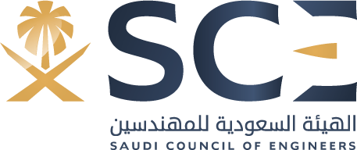
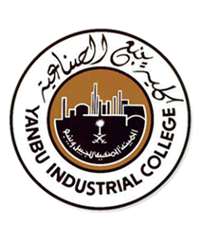
Saad Salman Alrashidi
Nationality: Saudi | Marital status: Single
Mobile: (+966-530638337) | Email: saadsalman1414@gmail.com
OBJECTIVE:
 | To get a job in any engineering department in a leading company that seeks to develop its employees and allow me to practice and develop my knowledge and skills that related to my major for both professional and personal growth.
EDUCATION:
April 2018  2016 - 2018  2012 – 2015 |  | Passed the SCE Fundamentals of Engineering (FE) Examination.  Yanbu Industrial College Bachelor Degree  Major: Electronic Engineering Technology  Yanbu Industrial College Associate of Science  Major: Science in Electronics Technology
SKILLS:
Technical Skills:  Personal Skills: | - Good Knowledge of Distributed Control System ( DCS) .  - Familiar with many design programs such as (MATLAB, Multisim and ADS).  - Intermediate at SAP.  - Well Qualified in preparing engineering reports.  - Team work.  - Willingness to learn more.  - Fast Learner.
TRAINING:
June 2017 To August 2017  June 2015 To October 2015 |  | SABIC – YANSAB as a Trainee.  (Managed to apply my study at the field and learned new types of systems).  General Utilities Department – Royal Commission as a Trainee.  (Learned the job responsibilities and the difference between it and the college life).
COURSES:
17 August 2017  25 July 2017  14 April 2016 |  | Introduction of SAP – YANSAB Company.  First Aid Certificate – YANSAB Clinic.  Basics of Mobile Maintenance – Technical and Vocational Training Corporation.
LANGUAGES:
English (Fluent).
Arabic (Native).

